1. Install Power BI Desktop and share the final screenshot of the report view page which appears when power desktop starts.

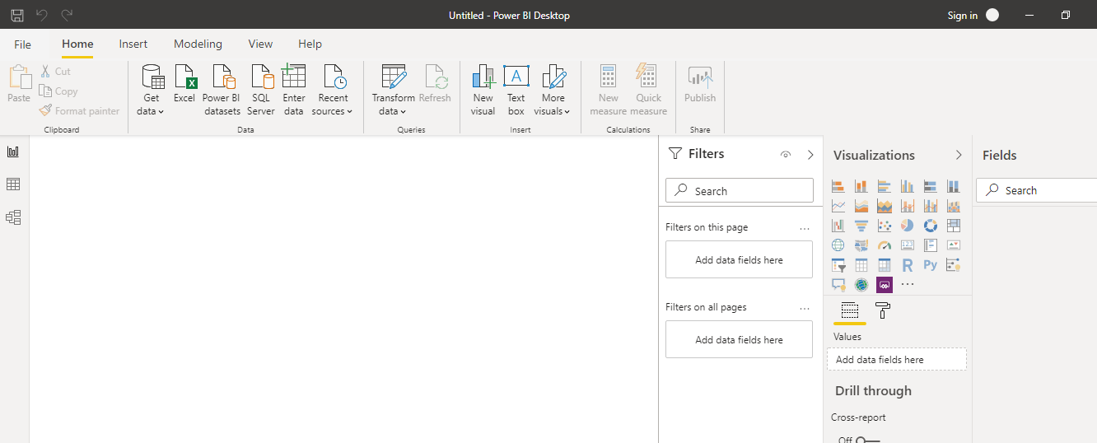

1. Prepare a document and with the following screenshot

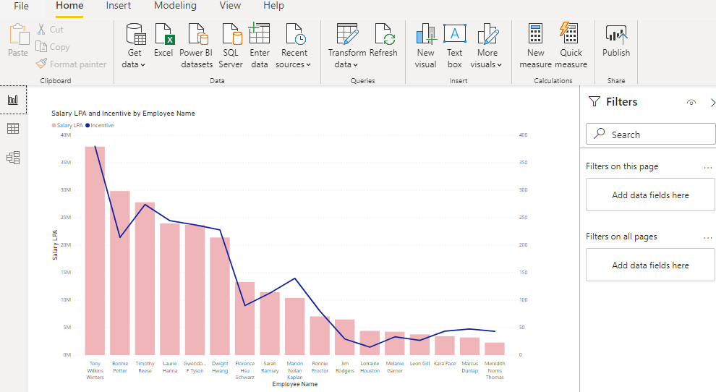− Report View

− Data View

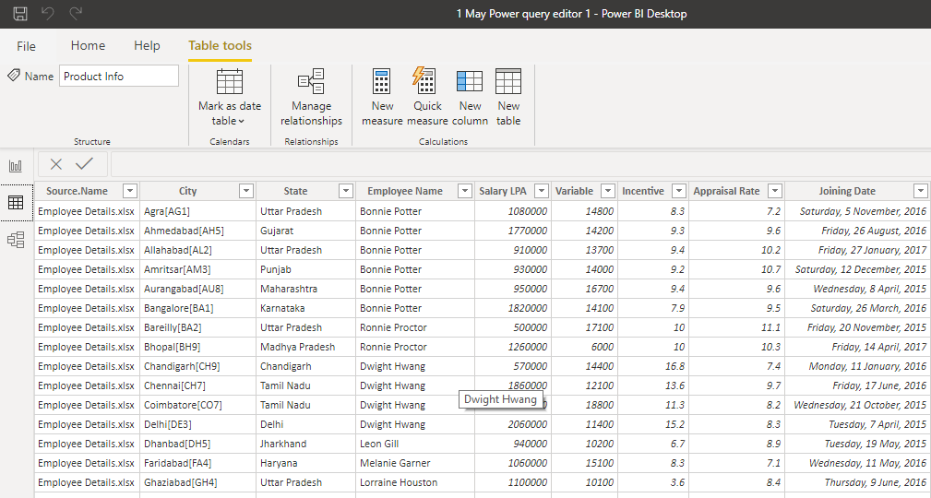

− Model View

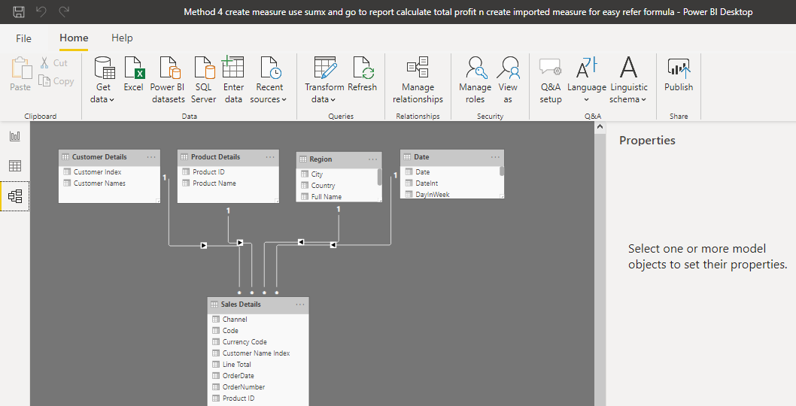

− Power Query Editor

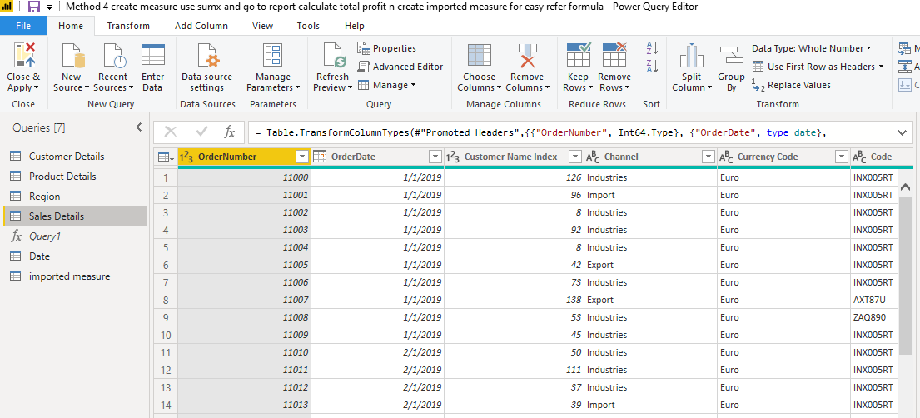

− Advance Editor

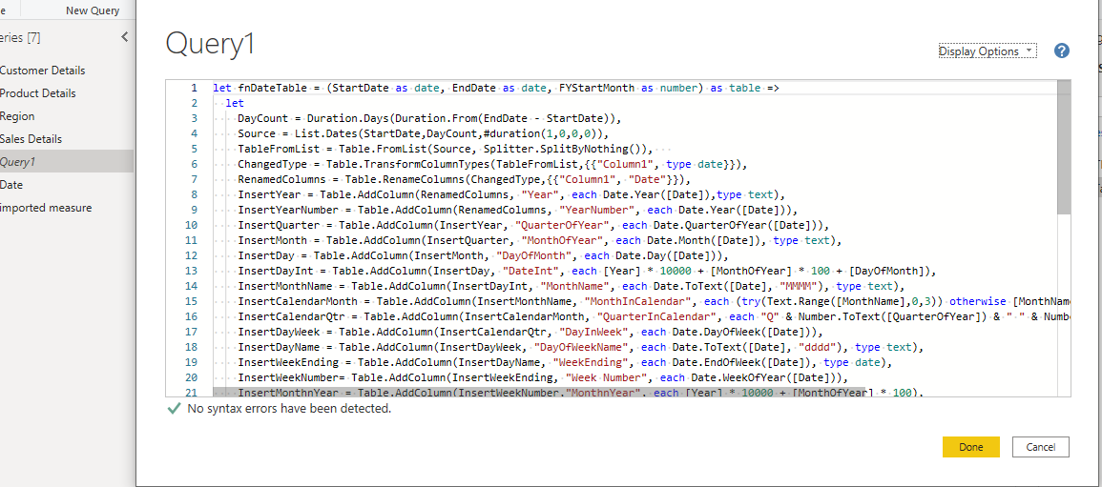

• Prepare a document with details of the following along with their price

− Power BI Desktop − Power BI Pro − Power BI Premium

